* Approximately 26 ppb of isoprene and 77 ppb toluene.
* 100 ml sampled.

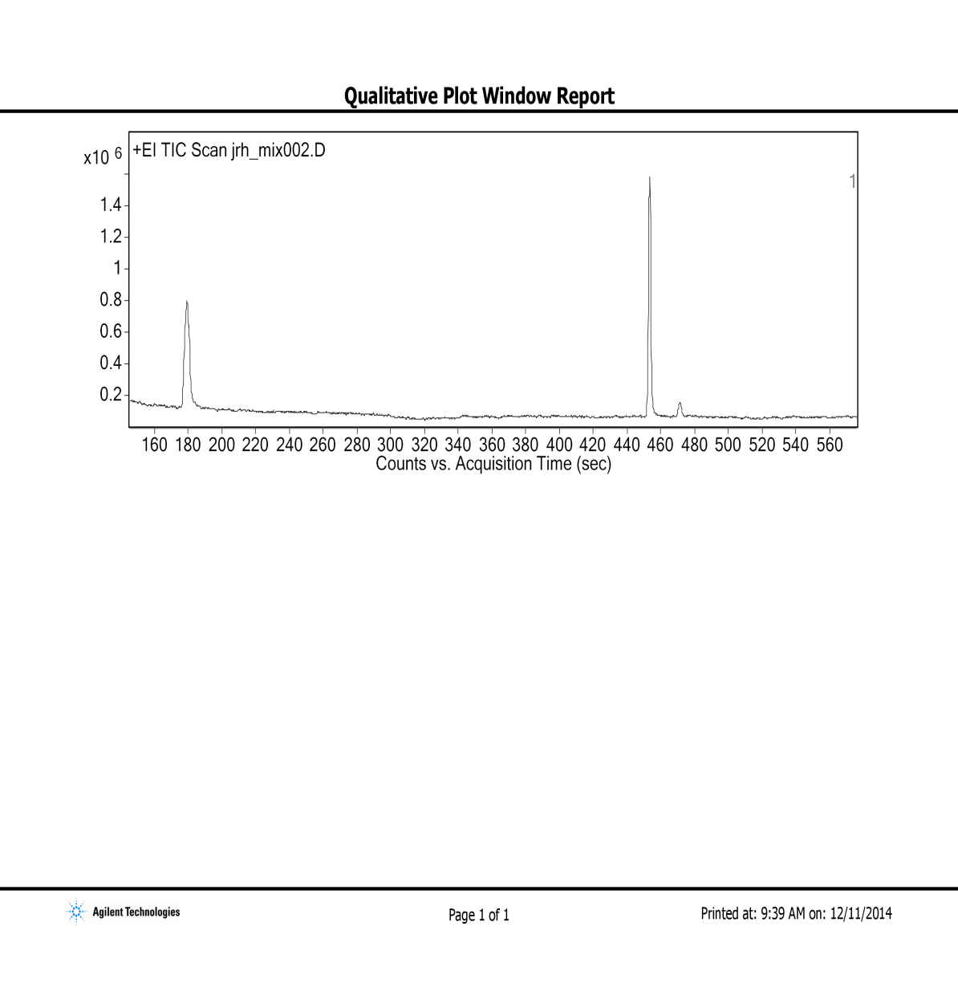

Isoprene

Toluene

1. Separation of the isoprene and toluene gas mixture and detection by TOF/MS.

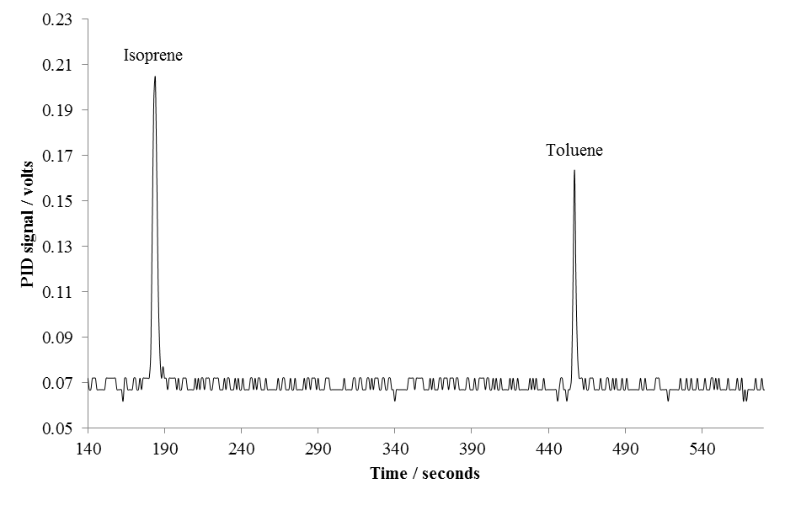

1. Separation of the isoprene and toluene gas mixture and detection by low-power low-cost PID.

* 1000 ml of the 4 nmol/mol standard gas mixture.

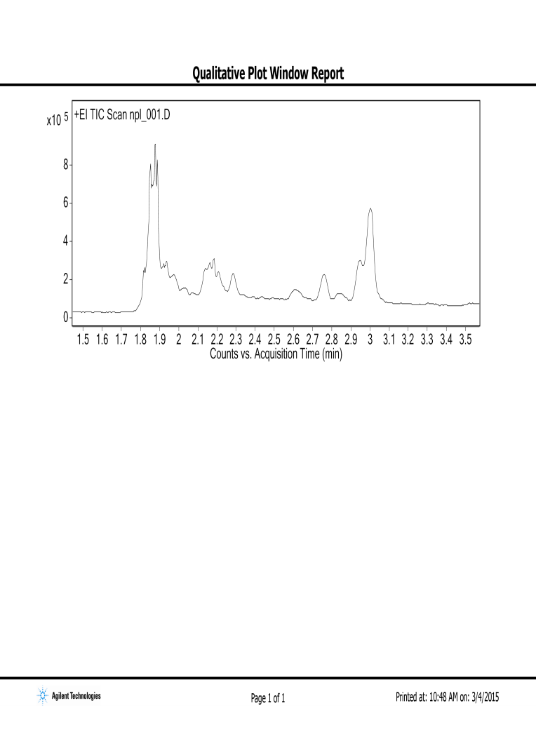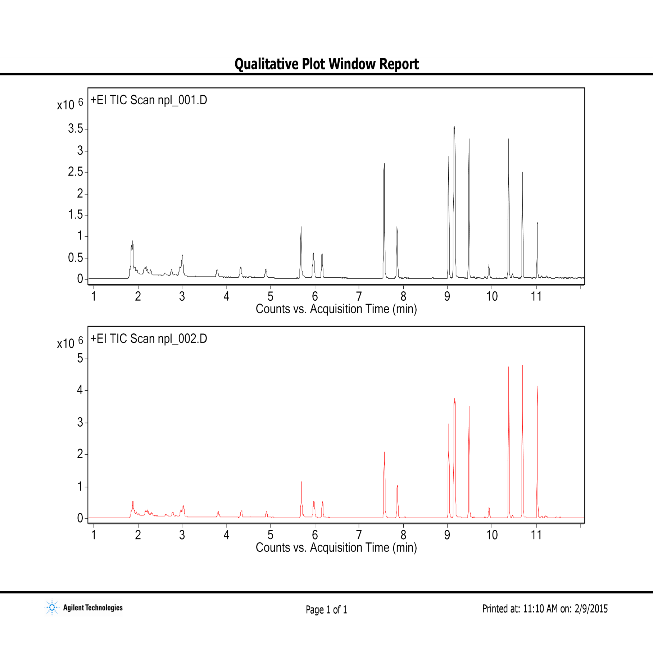

Benzene

Ethylbenzene

*trans*-2-butene*­­*

Pent-1-ene

*cis*-2-butene*­­*

2-methyl-butane

Pentane

*trans*-2-pentene*­­*

Isoprene

2,2,4-trimethyl-pentane

Toluene

1,3,5-trimethyl-benzene

1,2,4-trimethyl-benzene

1,2,3-trimethyl-benzene

*o*-xylene

*m+p*-xylene

Octane

2-methyl-pentane

Hexane

Heptane

1. Separation of the 4 ppb standard gas mixture and detection by laboratory standard TOF/MS detector.



1. Separation of the 4 ppb standard gas mixture and detection by low-power low-cost PID.